# Convolutions Lab week 2

Jacob Howard

1. Explain this phenomenon with respect to the block diagram of the system in figure 1.

The adder input gains are multiplied by the input signal and each signal is delayed

before being ran thorugh the adder. A delay of 0,1,2 using the Laplace Transforms.

1. This phenomenon is expected in real-life system. IN a circuit, what electrical component would

create the presence of ‘delayed energy’.

A capacitor

1. Explain this in your lab notebook in your own words. (equation 1)

The output of this equation is equal to the input signal multiplied by the time-shift and

gain of the system.

1. In your lab notebook, draw two copies of the unit pulse response with one shifted one-time step

to the right. Now add these signals together. Compare the two-unit pulse responses added

together to the measured output of the system.

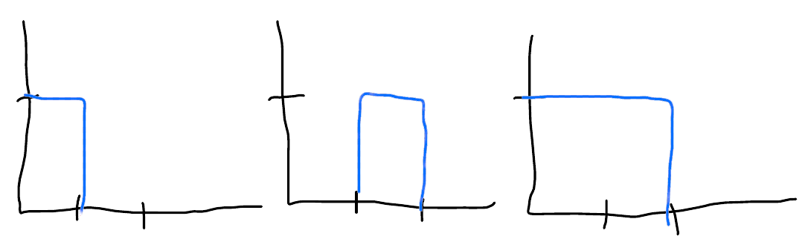

5. What would you expect if the input was four pulses back to back?

The output would be 4 times the pulse width

Feedback: This week’s lab was simple with the main purpose feeling like the labs want us to be very good at doing convolutions. This labs and past labs have made it a lot easier to learn convolutions instead of just the online lectures.